Last update: 31.03.2022

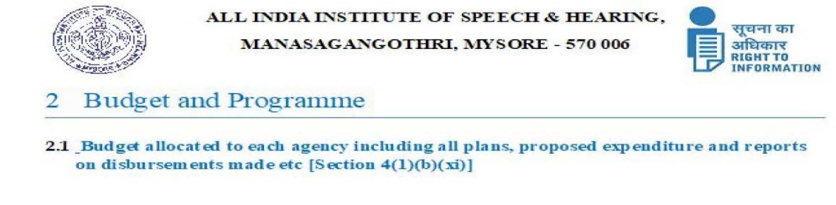

|  |  |  |  |
| --- | --- | --- | --- |
| Budget allocated to each Department/Section/Scheme/Activity including all plans, proposed expenditure and reports on disbursements made etc. (2021-22) | | | |
| (a)   Total Budget for the public authority - 130.00 Crores | | | |
|  |  |  |  |
| (b) Budget for each department/section/ plan / programmes/ Schemes | | | |
|  | **Amount in Crores** | |  |
|  | **Object Head Wise** | **BE-2021-22** |  |
|  | General | 21.72 |  |
|  | Capital | 92.30 |  |
|  | Salaries | 14.41 |  |
|  | Swatchhta Action Plan | 1.57 |  |
|  | **Total** | **130.00** |  |
|  |  |  |  |
| (c) Proposed expenditure : | |  |  |
|  | **Amount in Crores** | |  |
|  | **Object Head Wise** | **RE-2021-22** |  |
|  | General | 25.94 |  |
|  | Capital | 1.00 |  |
|  | Salaries | 18.29 |  |
|  | Swatchhta Action Plan | - |  |
|  | **Total** | **45.23** |  |
|  |  |  |  |
| (d) Revised budget for each department/section/ plan / programmes/ Schemes | | | |
|  | **Amount in Crores** | |  |
|  | **Object Head Wise** | **RE-2021-22** |  |
|  | General | 25.94 |  |
|  | Capital | 1.00 |  |
|  | Salaries | 18.29 |  |
|  | Swatchhta Action Plan | - |  |
|  | **Total** | **45.23** |  |
|  | (e) Report on disbursements made and place where the related reports are available-**Accounts Section** | | |